NOTICES
Assistant Priest: Rev. Tony Clapham
email: rev.tony.clapham@mail.com Please note Tony’s day off is Saturday
- Morning Prayer is on Tuesday at 9.30am.
- The Movement to Music class is on Thursday at 10am. It involves standing and sitting exercises suitable for all abilities. All are welcome
- Midweek Service takes place on Wednesday at 12.45pm. Please feel free to come along from 12.30pm onwards for short lunch time service which is open to all. On every second Wednesday of the month we will be having Communion with Reserved Sacrament Prof Ian Arbon will be presiding.
- Christian Aid Concert
Christian Aid are delighted to say that they exceeded their fundraising target. Thanks to the audience's generous donations, the sum raised was £1,057.03. This is an excellent start for this area's fundraising effort for the 2026 Christian Aid Appeal. During Christian Aid Week (10 - 17 May) there will be a collection in Tesco's large supermarket in Kilmarnock on Saturday afternoon.
- The Mothers Union is again collecting cleaning items for EACHA (East Ayrshire Council Homeless Action) to give people moving from supported accommodation to their own tenancy. The items are washing up bowl, washing up brush, dustpan and brush, toilet brush, cleaning spray (kitchen and bathroom) J clothes, tea towel. Please add one or two items to your shopping and put them in the box at the back of the church – thank you.




Fourth Sunday of Easter - 26 April 2026 Prof Ian Arbon will be presiding
Collect
O God, the light of whose truth stretches out to those who go astray, that they may return to the path of righteousness: give your grace to all who profess themselves Christians, that they may cast out what is harmful, and pursue all that gives life; through Jesus Christ, our Lord, who lives and reigns with you, in the unity of the Holy Spirit, one God, world without end. Amen

Hymns
Processional 6 All Creatures of our God and King
Gradual 649 The King of love (Tune 2)
Offertory 503 O Jesus I have (Tune 2)
Communion 87 Broken for me
Communion 787 Come into His presence
Recessional 186 For the healing of the nations

Communion
Everyone is welcome to receive Communion. We offer both bread and wine sipped from the common cup. We no longer offer intinction. Receiving in one kind is also a complete Communion. If you prefer this option, simply come forward to receive the bread then return to your seat. If you wish to receive a blessing from the priest, please indicate this by placing your hands on your chest. If you wish to receive Communion in your pew or require gluten-free bread please inform one of the welcome team. During the offertory hymn the collection will be taken at the pew. If you wish to donate to the church by another means, or to gift aid your donation please contact Ian, the Treasurer or Doreen. Thank you for your generosity.

First Reading - Acts 2:42-47

⁴² They devoted themselves to the apostles’ teaching and fellowship, to the breaking of bread and the rayers.⁴³ Awe came upon everyone because many wonders and signs were being done through the apostles. ⁴⁴ All who believed were together and had all things in common; ⁴⁵ they would sell their possessions and goods and distribute the proceeds to all, as any had need. ⁴⁶ Day by day, as they spent much time together in the temple, they broke bread at home and ate their food with glad and generous] hearts, ⁴⁷ praising God and having the goodwill of all the people. And day by day the Lord added to their number those who were
Second Reading - 1 Peter 2:19-25

¹⁹ For it is a commendable thing if, being aware of God, a person endures pain while suffering unjustly. ²⁰ If you endure when you are beaten for doing wrong, what credit is that? But if you endure when you do good and suffer for it, this is a commendable thing before God. ²¹ For to this you have been called, because Christ also suffered for you, leaving you an example, so that you should follow in his steps.²² “He committed no sin, and no deceit was found in his mouth.”²³ When he was abused, he did not return abuse; when he suffered, he did not threaten, but he entrusted himself to the one who judges justly. ²⁴ He himself bore our sins in his body on the cross, so that, having died to sins, we might live for righteousness; by his wounds you have been healed. ²⁵ For you were going astray like sheep, but now you have returned to the shepherd and guardian of your souls.
GOSPEL - John 10:1-10

¹ ‘Very truly, I tell you, anyone who does not enter the sheepfold by the gate but climbs in by another way is a thief and a bandit. ² The one who enters by the gate is the shepherd of the sheep. ³ The gatekeeper opens the gate for him, and the sheep hear his voice. He calls his own sheep by name and leads them out. ⁴ When he has brought out all his own, he goes ahead of them, and the sheep follow him because they know his voice. ⁵ They will not follow a stranger, but they will run from him because they do not know the voice of strangers.’ ⁶ Jesus used this figure of speech with them, but they did not understand what he was saying to them.⁷ So again Jesus said to them, ‘Very truly, I tell you, I am the gate for the sheep. ⁸ All who came before me are thieves and bandits; but the sheep did not listen to them. ⁹ I am the gate. Whoever enters by me will be saved, and will come in and go out and find pasture. ¹⁰ The thief comes only to steal and kill and destroy. I came that they may have life, and have it abundantly.

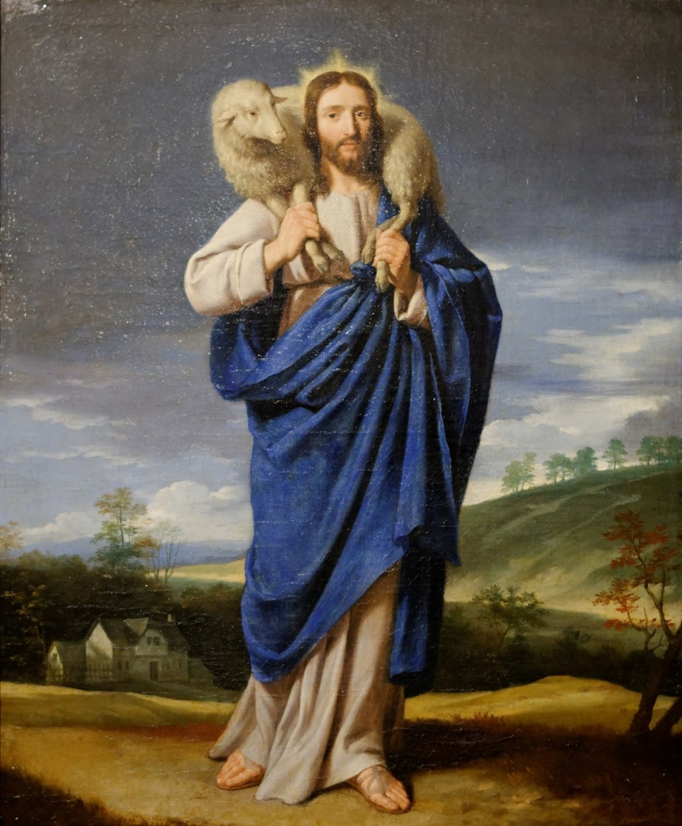

Le Bon Pasteur / The Good Shepherd Artist: Attributed to Philippe de Champaigne (1602–1674)

