NOTICES
Assistant Priest: Rev. Tony Clapham
email: rev.tony.clapham@mail.com Please note Tony’s day off is Saturday

- Morning Prayer is on Tuesday at 9.30am.
- The Movement to Music class is on Thursday at 10am. It involves standing and sitting exercises suitable for all abilities. All are welcome
- Midweek Service takes place on Wednesday at 12.45pm. Please feel free to come along from 12.30pm onwards for short lunch time service which is open to all. On every second Wednesday of the month we will be having Communion with Reserved Sacrament Prof Ian M Arbon will be presiding.
- St Columba's Largs on their 150th celebration to our churches in the Ayrshire Region.
We are planning to hold an open-air communion at St Blanes Chapel ruins on Bute. on Saturday 13th June. We are inviting Largs churches together as well as all local SEC to join with us for a day’s pilgrimage. If you are interested then let St Columba’s Church know by 20th May at moran@btinternet.com. It does involve some walking uphill, so it won’t be suitable for all.
- The Mothers Union is again collecting cleaning items for EACHa to give people moving from supported accommodation to their own tenancy. The items are washing up bowl, washing up brush, dustpan and brush, toilet brush, cleaning spray (kitchen and bathroom) J clothes, tea towel. Please add one or two items to your shopping and put them in the box at the back of the church – thank you.
- The Keswick Ayrshire Convention will be held at the Park Hotel on the evenings of 29 to 31 May. Entry is free and there will be an opportunity to make donations. The theme is “Finding God in Hard Places”. The Keynote speaker, Ian Coffey, is a Baptist Minister who has led churches in British and international contexts. He speaks at conferences in many parts of the world and has written 14 books. His passion is to teach the Bible in language people can understand. At Moorlands College Ian specializes in leadership training and development
- Created to Belong - Celebrating Disability in the Image of God. This event will be held on Saturday 23 May from 9.30 am to 4.30 pm at the Howard Centre, Portland Road, Kilmarnock. Its aim is to promote disability inclusion in places of worship and in the wider community. The event will be as accessible and inclusive as possible for people with learning disabilities, physical disabilities, people who are neurodivergent as well as those who are interested in inclusion. Guide dogs are welcome and British Sign Language interpreters will be present.


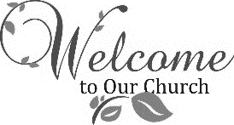

Seventh Sunday of Easter – 17th May 2026 Sunday after Ascension Day

Pat will be presiding along with Prof Ian M. Arbon who will be peaching
Collect
O God, the King of Glory, hear our prayer: that as we believe your Son Jesus Christ to be exalted with great triumph to your kingdom in heaven; so also we may know his presence with us now, and to the end of time; who lives and reigns with you, in the unity of the Holy Spirit, one God, world without end. Amen

Hymns
Processional 562 Praise Him
Gradual 120 Come let us join
Offertory 630 Tell His praise
Communion 304 I come with Joy
Communion 67 Be still for the presence of the Lord
Recessional 137 Crown Him with many crowns

Communion
Everyone is welcome to receive Communion. We offer both bread and wine sipped from the common cup. We no longer offer intinction. Receiving in one kind is also a complete Communion. If you prefer this option, simply come forward to receive the bread then return to your seat. If you wish to receive a blessing from the priest, please indicate this by placing your hands on your chest. If you wish to receive Communion in your pew or require gluten-free bread please inform one of the welcome team. During the offertory hymn the collection will be taken at the pew. If you wish to donate to the church by another means, or to gift aid your donation please contact Ian, the Treasurer or Doreen. Thank you for your generosity.

First Reading - Acts 1:1 -11

¹ In the first book, Theophilus, I wrote about all that Jesus began to do and teach ² until the day when he was taken up to heaven, after giving instructions through the Holy Spirit to the apostles whom he had chosen. ³ After his suffering[ he presented himself alive to them by many convincing proofs, appearing to them during forty days and speaking about the kingdom of God. ⁴ While staying with them, he ordered them not to leave Jerusalem but to wait there for the promise of the Father. “This,” he said, “is what you have heard from me; ⁵ for John baptized with water, but you will be baptized with the Holy Spirit not many days from now.”⁶ So when they had come together, they asked him, “Lord, is this the time when you will restore the kingdom to Israel?” ⁷ He replied, “It is not for you to know the times or periods that the Father has set by his own authority. ⁸ But you will receive power when the Holy Spirit has come upon you, and you will be my witnesses in Jerusalem, in all Judea and Samaria, and to the ends of the earth.” ⁹ When he had said this, as they were watching, he was lifted up, and a cloud took him out of their sight. ¹⁰ While he was going and they were gazing up toward heaven, suddenly two men in white robes stood by them. ¹¹ They said, “Men of Galilee, why do you stand looking up toward heaven? This Jesus, who has been taken up from you into heaven, will come in the same way as you saw him go into heaven.”

Second Reading - Ephesians 1:15-23

¹⁵ I have heard of your faith in the Lord Jesus and your love toward all the saints, and for this reason ¹⁶ I do not cease to give thanks for you as I remember you in my prayers, ¹⁷ that the God of our Lord Jesus Christ, the Father of glory, may give you a spirit of wisdom and revelation as you come to know him, ¹⁸ so that, with the eyes of your heart enlightened, you may perceive what is the hope to which he has called you, what are the riches of his glorious inheritance among the saints, ¹⁹ and what is the immeasurable greatness of his power for us who believe, according to the working of his great power. ²⁰ God put this power to work in Christ when he raised him from the dead and seated him at his right hand in the heavenly places, ²¹ far above all rule and authority and power and dominion and above every name that is named, not only in this age but also in the age to come. ²² And he has put all

things under his feet and has made him the head over all things for the church, ²³ which is his body, the fullness of him who fills all in all.
GOSPEL - Luke 24:44 - 53

⁴⁴ Then he said to them, “These are my words that I spoke to you while I was still with you - that everything written about me in the law of Moses, the prophets, and the psalms must be fulfilled.” ⁴⁵ Then he opened their minds to understand the scriptures, ⁴⁶ and he said to them, “Thus it is written, that the Messiah is to suffer and to rise from the dead on the third day ⁴⁷ and that repentance and forgiveness of sins is to be proclaimed in his name to all nations, beginning from Jerusalem. ⁴⁸ You are witnesses of these things. ⁴⁹ And see, I am sending upon you what my Father promised, so stay here in the city until you have been clothed with power from on high.”⁵⁰ Then he led them out as far as Bethany, and, lifting up his hands, he blessed them. ⁵¹ While he was blessing them, he withdrew from them and was carried up into heaven. ⁵² And they worshiped him and returned to Jerusalem with great joy, ⁵³ and they were continually in the temple blessing God.
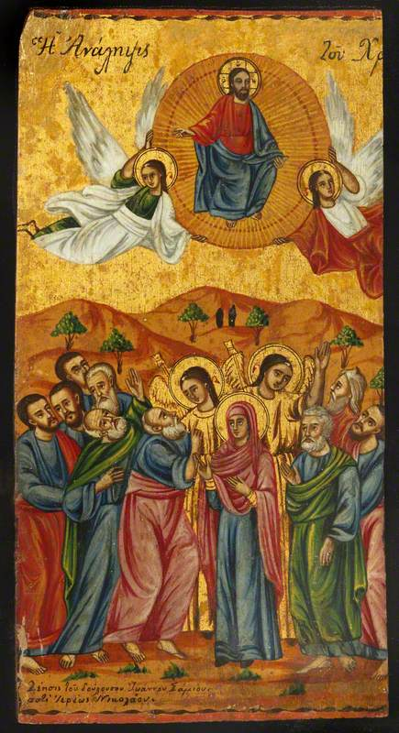

.

Icon with the Ascension of Christ
Image credit: Campion Hall, University of Oxford

